COMSATS University Islamabad

Lahore Campus



**Complex Engineering Problem Report**

**CPE314 - Data Communication and Computer Networks**

**Submitted To:** Sir Modassir Ishfaq

**Submitted By:** Abdullah Laeeq (FA22-BCE-026)

Table of Contents

1. Network Topology Diagram 3

2. Variable Subnetting Scheme 3

3. Connectivity Verification 5

4. Server Operability 7

5. Requirement Analysis 7

R1: IT Department Network Access and Telnet Connectivity 8

R2: Traffic Filtering – Permitting Only ICMP, DNS, DHCP, and HTTP to Network Operations Core 8

R3: Switch Security and Intrusion Prevention in IT Department 9

R4: Spanning Tree Protocol (STP) Configuration and Observations in SMT Network 10

R5: VLAN Configuration for Postpaid and Prepaid Subscriber Management in SMT Area 1 10

R6: Access Control Between OMD and Postpaid Subscriber Management Team 11

R7: Restricting OMD Access to NOC Webserver 12

R8: Access Restrictions Between Postpaid Billing and Prepaid Subscriber Management Teams 12

R9: DHCP Configuration for IPv4 Address Allocation Across Departments 13

R10: DNS Service Configuration and Accessibility 13

R11: Multi-Area OSPF Implementation and Route Summarization 14

R12: Efficient IP Address Allocation and Minimization of Wastage 14

R13: Ensuring Unique Bandwidth Allocation for Serial Links 14

R14: Cost Analysis of Selected Network Routes 15

6. Challenges 16

7. Commands per router

# 1. Network Topology

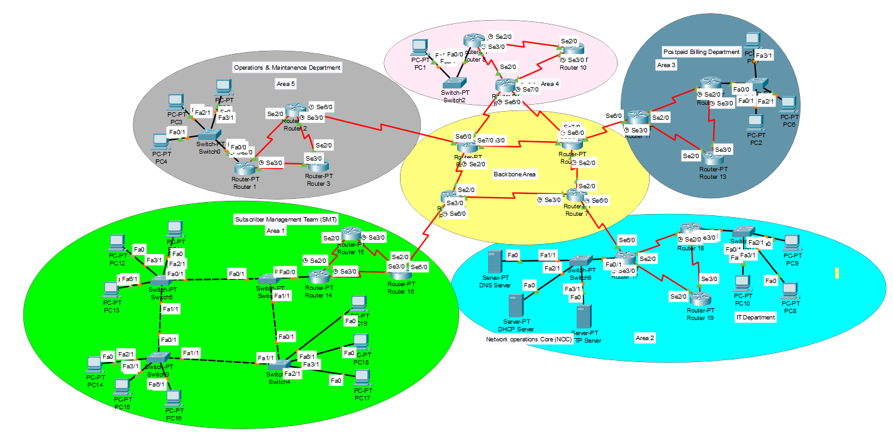

# 2. Variable Subnetting Scheme

The subnetting plan was tailored to fulfill the unique host requirements of each department and inter-router connections.

|  |  |  |  |  |  |  |  |
| --- | --- | --- | --- | --- | --- | --- | --- |
| Subnet  Name | Hosts  Available | Network Address | Slash | Subnet Mask | Usable Range | Broadcast | Area |
| SMT VLAN10 | 6 | 192.168.26.120 | /29 | 255.255.255.248 | 192.168.26.121 - 192.168.26.126 | 192.168.26.127 | 1 |
| SMT  VLAN20 | 6 | 192.168.26.128 | /29 | 255.255.255.248 | 192.168.26.129 – 192.168.26.134 | 192.168.26.135 | 1 |
| NOC LAN | 6 | 192.168.26.0 | /29 | 255.255.255.248 | 192.168.26.1 - 192.168.26.6 | 192.168.26.7 | 2 |
| IT LAN | 6 | 192.168.26.8 | /29 | 255.255.255.248 | 192.168.26.9 - 192.168.26.14 | 192.168.26.15 | 2 |
| PBD LAN | 6 | 192.168.26.48 | /29 | 255.255.255.248 | 192.168.26.49 -192.168.26.54 | 192.168.26.55 | 3 |
| Area4  LAN | 2 | 192.168.26.72 | /30 | 255.255.255.252 | 192.168.26.73 - 192.168.26.74 | 192.168.26.75 | 4 |
| OMD  LAN | 6 | 192.168.26.96 | /29 | 255.255.255.248 | 192.168.26.97 - 192.168.26.102 | 192.168.26.103 | 5 |
| R 7-6 | 2 | 192.168.26.32 | /30 | 255.255.255.252 | 192.168.26.33 -192.168.26.34 | 192.168.26.35 | 0 |
| R 7-5 | 2 | 192.168.26.36 | /30 | 255.255.255.252 | 192.168.26.37 -192.168.26.38 | 192.168.26.39 | 0 |
| R 6-4 | 2 | 192.168.26.40 | /30 | 255.255.255.252 | 192.168.26.41 - 192.168.26.42 | 192.168.26.43 | 0 |
| R 4-5 | 2 | 192.168.26.44 | /30 | 255.255.255.252 | 192.168.26.45 -192.168.26.46 | 192.168.26.47 | 0 |
| R 18-19 | 2 | 192.168.26.16 | /30 | 255.255.255.252 | 192.168.26.17 - 192.168.26.18 | 192.168.26.19 | 2 |
| R 18-17 | 2 | 192.168.26.20 | /30 | 255.255.255.252 | 192.168.26.21 - 192.168.26.22 | 192.168.26.23 | 2 |
| R 17 -19 | 2 | 192.168.26.24 | /30 | 255.255.255.252 | 192.168.26.25 - 192.168.26.26 | 192.168.26.27 | 2 |
| R 17-7 | 2 | 192.168.26.28 | /30 | 255.255.255.252 | 192.168.26.29 - 192.168.26.30 | 192.168.26.31 | 0 |
| R 12-13 | 2 | 192.168.26.56 | /30 | 255.255.255.252 | 192.168.26.57 - 192.168.26.58 | 192.168.26.59 | 3 |
| R 13-11 | 2 | 192.168.26.60 | /30 | 255.255.255.252 | 192.168.26.61 - 192.168.26.62 | 192.168.26.63 | 3 |
| R 11-12 | 2 | 192.168.26.64 | /30 | 255.255.255.252 | 192.168.26.65 - 192.168.26.66 | 192.168.26.67 | 3 |
| R 11-6 | 2 | 192.168.26.68 | /30 | 255.255.255.252 | 192.168.26.69 - 192.168.26.70 | 192.168.26.71 | 0 |
| R 8-10 | 2 | 192.168.26.76 | /30 | 255.255.255.252 | 192.168.26.77 - 192.168.26.78 | 192.168.26.79 | 4 |
| R 8-9 | 2 | 192.168.26.80 | /30 | 255.255.255.252 | 192.168.26.81 - 192.168.26.82 | 192.168.26.83 | 4 |
| R 9-10 | 2 | 192.168.26.84 | /30 | 255.255.255.252 | 192.168.26.85 - 192.168.26.86 | 192.168.26.87 | 4 |
| R 9-6 | 2 | 192.168.26.88 | /30 | 255.255.255.252 | 192.168.26.89 - 192.168.26.90 | 192.168.26.91 | 0 |
| R 9-4 | 2 | 192.168.26.92 | /30 | 255.255.255.252 | 192.168.26.93 - 192.168.26.94 | 192.168.26.95 | 0 |
| R 1-3 | 2 | 192.168.26.104 | /30 | 255.255.255.252 | 192.168.26.105 - 192.168.26.106 | 192.168.26.107 | 5 |
| R 1-2 | 2 | 192.168.26.108 | /30 | 255.255.255.252 | 192.168.26.109 - 192.168.26.110 | 192.168.26.111 | 5 |
| R 2-3 | 2 | 192.168.26.112 | /30 | 255.255.255.252 | 192.168.26.113 - 192.168.26.114 | 192.168.26.115 | 5 |
| R 2-4 | 2 | 192.168.26.116 | /30 | 255.255.255.252 | 192.168.26.117 - 192.168.26.118 | 192.168.26.119 | 0 |
| R 14-15 | 2 | 192.168.26.136 | /30 | 255.255.255.252 | 192.168.26.137 - 192.168.26.138 | 192.168.26.139 | 1 |
| R 15-16 | 2 | 192.168.26.140 | /30 | 255.255.255.252 | 192.168.26.141 - 192.168.26.142 | 192.168.26.143 | 1 |
| R 14-16 | 2 | 192.168.26.144 | /30 | 255.255.255.252 | 192.168.26.145 - 192.168.26.146 | 192.168.26.147 | 1 |
| R 5-16 | 2 | 192.168.26.148 | /30 | 255.255.255.252 | 192.168.26.149 - 192.168.26.150 | 192.168.26.151 | 0 |

# 3. Connectivity Verification

Connectivity across the network was validated using various methods. This includes traceroute and ping tests between different departments and across OSPF areas, as well as OSPF neighbor and route table checks. These tests confirmed that all devices can communicate as intended, and that routing is functioning correctly throughout the network.

3.1. Traceroutes

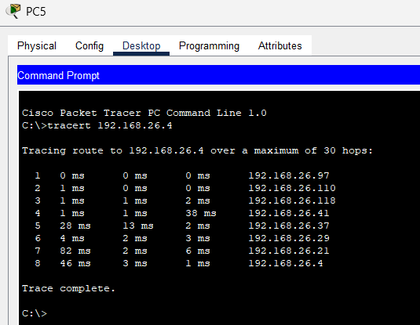

*Sample traceroute from OMD* to IT Department

3.2. Pings

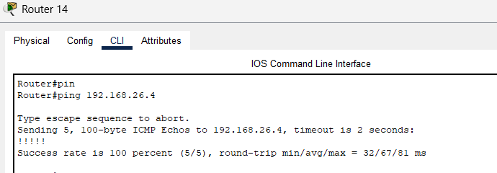

*Sample ping from Area 1 to Area 2*

3.3. OSPF 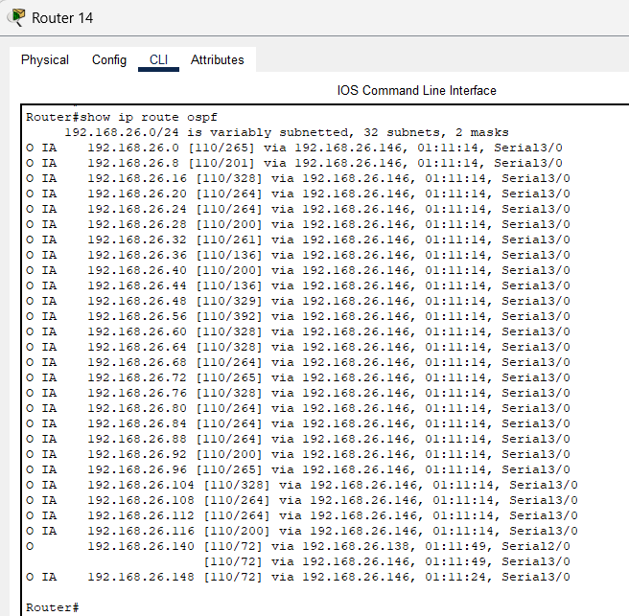

# 4. Server Operability

This section evaluates the setup and operation of major network services. Checks were performed on DNS, DHCP, and HTTP servers to confirm they are up and running and providing the proper functionality to clients in different parts of the network. Successful results show that the services are configured appropriately and well integrated with the network.

4.1. HTTP

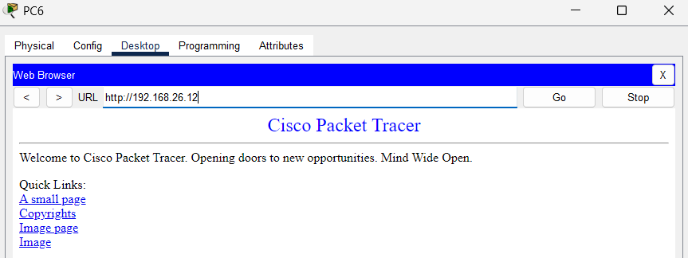

4.2. DNS

4.3. DHCP

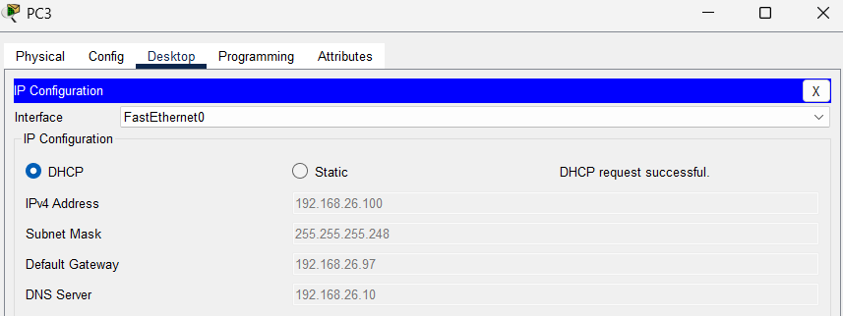

# 5. Requirement Analysis

This section details how each project requirement was addressed through the network’s design and setup. It outlines the specific measures taken to meet the defined objectives, including securing access, filtering traffic, establishing VLANs, configuring OSPF across various areas, efficiently managing IP address allocation, and assigning dedicated bandwidth to serial links. Each requirement is linked to its respective configuration and the results of the corresponding tests.

## R1: IT Department Network Access and Telnet Connectivity

Access Control Lists (ACLs) are set up on the virtual terminals (VTY) of all routers, permitting only the IT department's LAN (192.168.86.41/29) to establish Telnet connections to these routers. All other Telnet connection attempts are denied. In this setup, the IT department is connected to Router 18 via Telnet:

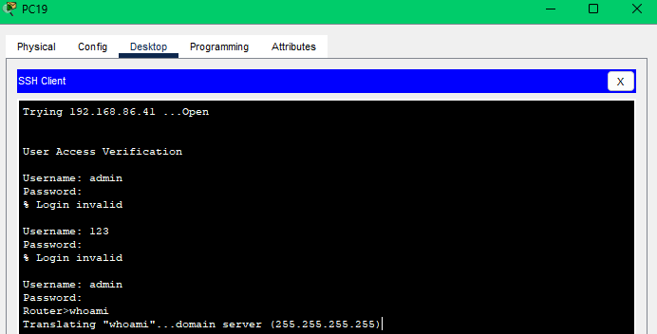

But Router 18 is refusing telnet from Postpaid Billing Department, while allowing pings.

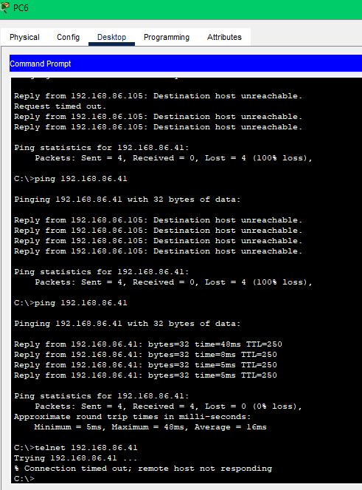

## R3: Switch Security and Intrusion Prevention in IT Department

Port security is set up on the IT department switch, shutting down any ports on a MAC address violation.

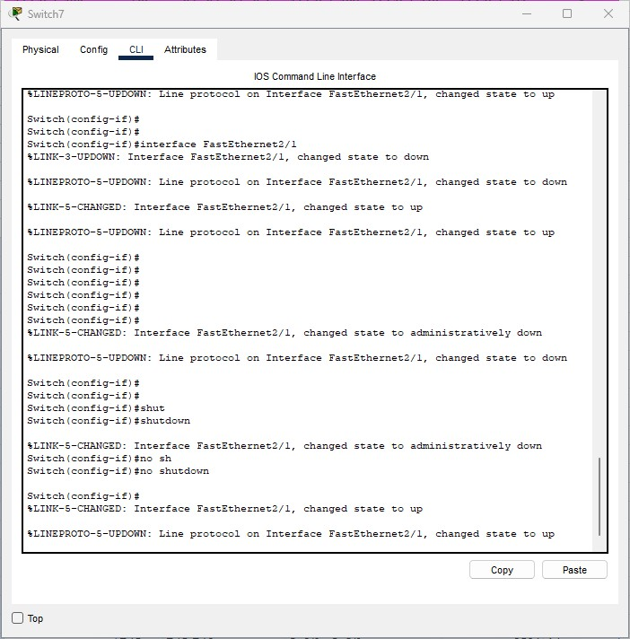

## R4: Spanning Tree Protocol (STP) Configuration and Observations in SMT Network

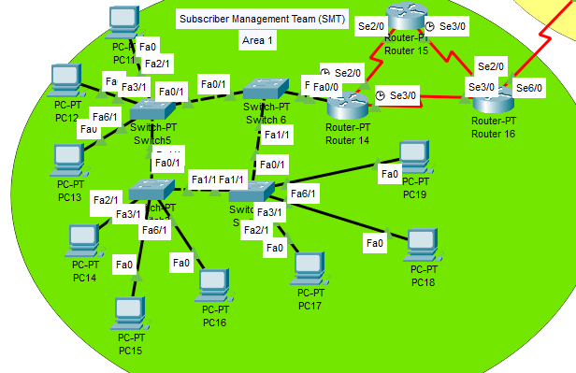

The output shows that Spanning Tree Protocol (STP) is active on the switch across multiple VLANs, such as VLAN 10 and VLAN 20. This protocol helps avoid Layer 2 loops by electing a root bridge and blocking redundant links in the network. Each VLAN operates its own STP instance, allowing the switch to identify root and designated ports based on the algorithm’s process.

## R5: VLAN Configuration for Postpaid and Prepaid Subscriber Management in SMT Area 1

SMT department has two VLANs – VLAN 10 and VLAN 20 for Postpaid and Prepaid teams. Each VLAN is identified by a sub-interface on the first hop router and uses Dot1Q encapsulation.

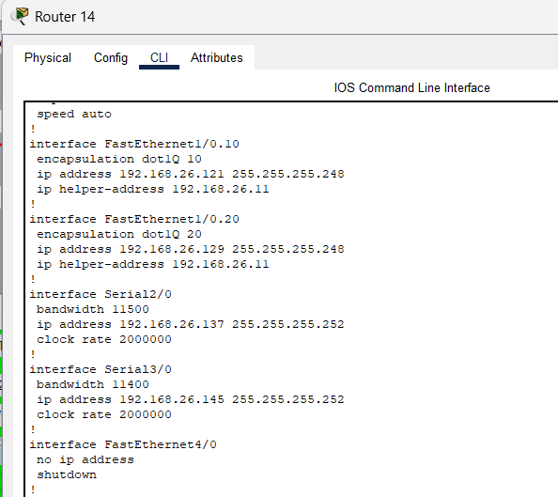

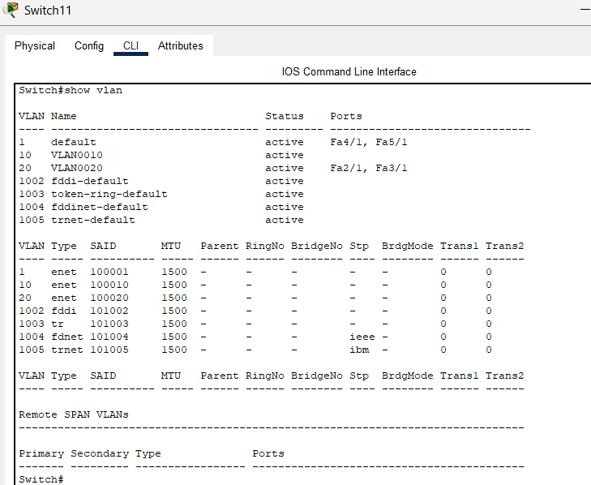

## R6: Access Control Between OMD and Postpaid Subscriber Management Team

OMD can connect to the Prepaid Subscriber Management Team, but access is restricted for Postpaid Team – defined by an ACL at the OMD first hop router.

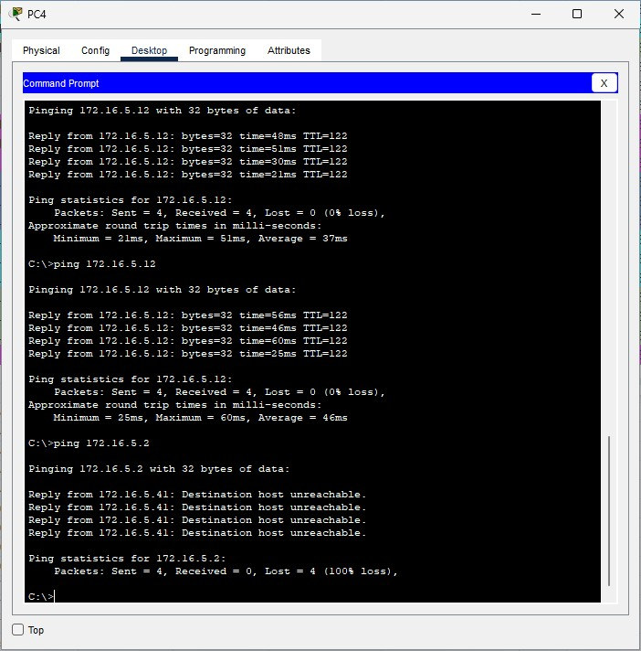

## R7: Restricting OMD Access to NOC Webserver

ACL on OMD ABR denies access to the webserver at NOC.

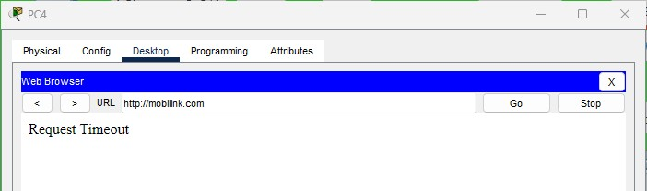

## R8: Access Restrictions Between Postpaid Billing and Prepaid Subscriber Management Teams

ACL configured on first hop router in SMT blocks inter VLAN communication.

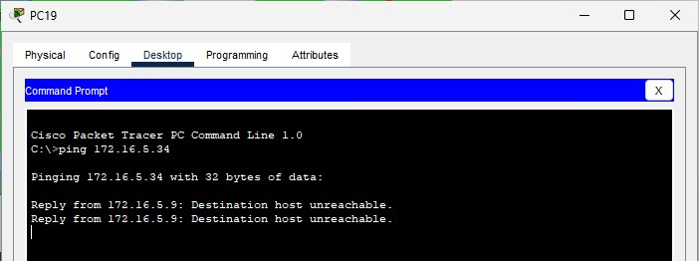

## R9: DHCP Configuration for IPv4 Address Allocation Across Departments

DHCP server offers these pools for the configured areas, as well as DNS.

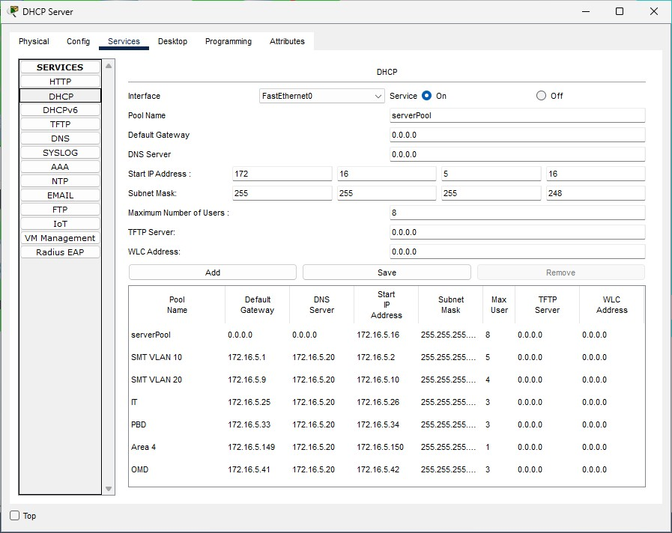

## R10: DNS Service Configuration and Accessibility

DNS server translates Mobilink.com to the HTTP server IPv4 address.

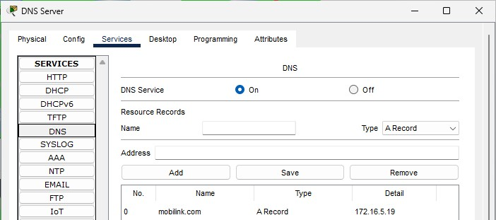

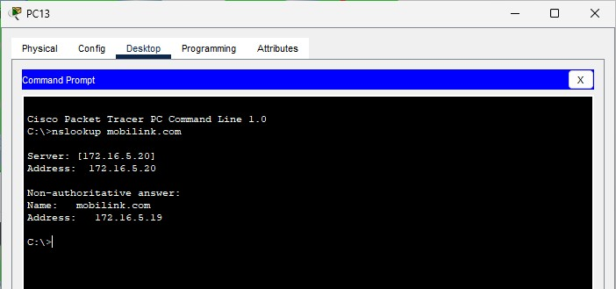

## R11: Multi-Area OSPF Implementation and Route Summarization

Multi-area OSPF was implemented to improve scalability and manageability. Route summarization was planned at area border routers to reduce the size of routing tables and limit the propagation of detailed network information between areas. However, effective summarization was only possible for Area 1 due to its contiguous subnet allocation.

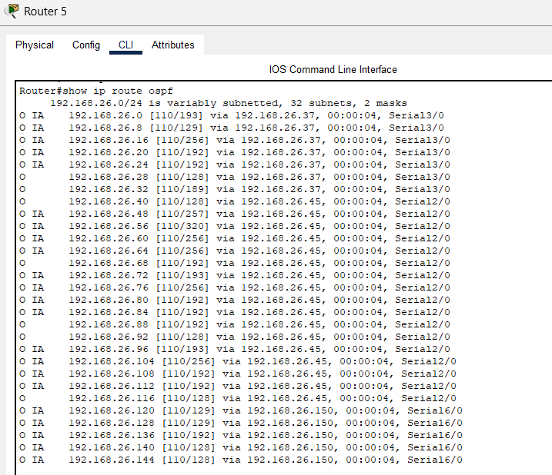

## R12: Efficient IP Address Allocation and Minimization of Wastage

Refer to VLSM scheme provided above.

## R13: Ensuring Unique Bandwidth Allocation for Serial Links

Following table provides details on each link and its bandwidth.

|  |  |  |  |  |
| --- | --- | --- | --- | --- |
| Router | Link | Interface | Bandwith | Description |
| R1 | R1-R2 | Se2/0 - Se2/0 | 10240 | A5 |
| R2 | R2-R3 | Se3/0 - Se2/0 | 10752 | A5 |
| R3 | R3-R1 | Se3/0 - Se3/0 | 11264 | A5 |
| R4 | R4-R2 | Se6/0 - Se6/0 | 8192 | A5 ABR |
| R4-R6 | Se3/0 - Se3/0 | 64 | BB |
| R4-R9 | Se7/0 - Se6/0 | 1536 | A4 ABR |
| R5 | R5-R16 | Se6/0 - Se6/0 | 1024 | A1 ABR |
| R5-R4 | Se2/0 - Se2/0 | 512 | BB |
| R6 | R6-R11 | Se6/0 - Se6/0 | 4096 | A3 ABR |
| R6-R7 | Se2/0 - Se2/0 | 128 | BB |
| R6-R9 | Se7/0 - Se7/0 | 2304 | A4 ABR |
| R7 | R7-R17 | Se6/0 - Se6/0 | 2048 | A2 ABR |
| R7-R5 | Se3/0 - Se3/0 | 256 | BB |
| R8 | R8-R9 | Se3/0 - Se2/0 | 8704 | A4 |
| R9 | R9-R10 | Se3/0 - Se3/0 | 9216 | A4 |
| R10 | R10-R8 | Se2/0 - Se2/0 | 9728 | A4 |
| R11 | R11-R12 | Se2/0 - Se2/0 | 6656 | A3 |
| R12 | R12-R13 | Se3/0 - Se3/0 | 7168 | A3 |
| R13 | R13-R11 | Se2/0 - Se3/0 | 7680 | A3 |
| R14 | R14-R15 | Se2/0 - Se2/0 | 3072 | A1 |
| R15 | R15-R16 | Se3/0 - Se2/0 | 3584 | A1 |
| R16 | R16-R14 | Se3/0 - Se3/0 | 4608 | A1 |
| R17 | R17-R18 | Se2/0 - Se2/0 | 5120 | A2 |
| R18 | R18-R19 | Se3/0 - Se3/0 | 5632 | A2 |
| R19 | R19-R17 | Se2/0 - Se3/0 | 6144 | A2 |

## R14: Cost Analysis of Selected Network Routes

1. PC4 to PC10

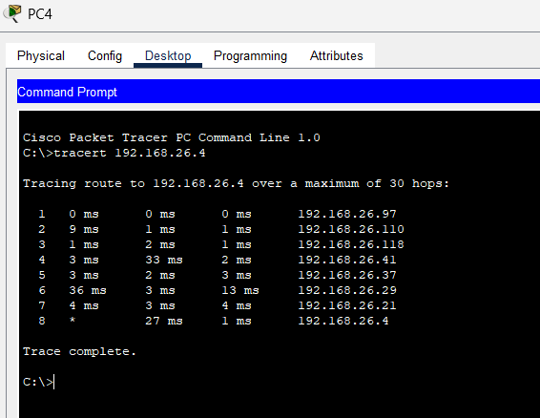

The route is R1 – R2 – R4 – R9 – R6 – R7 – R7 – R18. The sum of OSPF costs is 9 + 12 + 65 + 43 + 64 + 49 + 19 = 261, as confirmed by the router.

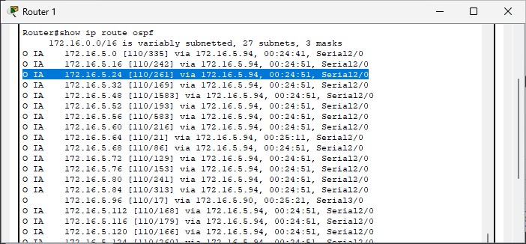

# 6. Challenges

Due to inefficient subnetting in the network design, I was only able to tightly summarize the routes within OSPF Area 1. The subnets in Area 1 were contiguous and aligned in such a way that they could be aggregated into a single summary address without including unrelated subnets. However, the subnets in the rest of the network were fragmented and not contiguous, making it impossible to summarize them effectively without causing overlap with other subnets.

Router 18

Router(config)#int fa 0/0

Router(config-if)#ip addr 192.168.26.1 255.255.255.252

Router(config-if)#no shut

Router(config-if)#exit

Router(config)#int se 2/0

Router(config-if)#ip addr 192.168.26.21 255.255.255.252

Router(config-if)#no shut

Router(config-if)#exit

Router(config)#int se 3/0

Router(config-if)#ip addr 192.168.26.21 255.255.255.252

Router(config-if)#no shut

Router(config-if)#exit

--OSPF

Router(config)#router ospf 1

Router(config-router)#network 192.168.26.0 0.0.0.7 area 2

Router(config-router)#network 192.168.26.16 0.0.0.3 area 2

Router(config-router)#network 192.168.26.20 0.0.0.3 area 2

Router(config-router)#exit

Router(config)#int fa 0/0

Router(config-if)#ip helper-address 192.168.26.11

Router(config-if)#exit

-------------------

Requirement:1

-------------------

configure terminal

access-list 150 permit icmp any any

access-list 150 permit tcp any any eq 23

interface Serial 2/0

ip access-group 150 out

exit

interface Serial 3/0

ip access-group 150 out

exit

access-list 151 permit icmp any any echo-reply

access-list 151 deny ip any any

interface FastEthernet0/0

ip access-group 151 in

exit

===========================================================

--Router 19

Router(config)#int se 3/0

Router(config-if)#ip addr 192.168.26.18 255.255.255.252

Router(config-if)#no shut

Router(config)#int se 2/0

Router(config-if)#ip addr 192.168.26.26 255.255.255.252

Router(config-if)#no shut

--OSPF

Router(config)#router ospf 1

Router(config-router)#network 192.168.26.16 0.0.0.3 area 2

Router(config-router)#network 192.168.26.24 0.0.0.3 area 2

Router(config-router)#exit

===========================================================

--Router 17

Router(config)#int se 3/0

Router(config-if)#ip addr 192.168.26.25 255.255.255.252

Router(config-if)#no shut

Router(config)#int se 2/0

Router(config-if)#ip addr 192.168.26.22 255.255.255.252

Router(config-if)#no shut

Router(config)#int se 6/0

Router(config-if)#ip addr 192.168.26.29 255.255.255.252

Router(config-if)#no shut

Router(config)#int fa 0/0

Router(config-if)#ip addr 192.168.26.9 255.255.255.248

Router(config-if)#no shut

--OSPF

Router(config)#router ospf 1

Router(config-router)#network 192.168.26.8 0.0.0.7 area 2

Router(config-router)#network 192.168.26.20 0.0.0.3 area 2

Router(config-router)#network 192.168.26.20 0.0.0.3 area 2

Router(config-router)#network 192.168.26.28 0.0.0.3 area 0

Router(config-router)#exit

enable

configure terminal

enable password 123

username admin password 123

line vty 0 4

password 123

login local

exit

line console 0

password 123

login local

exit

exit

wr

--ACL

==========================================================

--Router 7

Router(config)#int se 6/0

Router(config-if)#ip addr 192.168.26.30 255.255.255.252

Router(config-if)#no shut

Router(config)#int se 2/0

Router(config-if)#ip addr 192.168.26.33 255.255.255.252

Router(config-if)#no shut

Router(config)#int se 3/0

Router(config-if)#ip addr 192.168.26.37 255.255.255.252

Router(config-if)#no shut

--OSPF

Router(config)#router ospf 1

Router(config-router)#network 192.168.26.32 0.0.0.7 area 0

Router(config-router)#network 192.168.26.36 0.0.0.7 area 0

Router(config-router)#network 192.168.26.28 0.0.0.7 area 0

Router(config-router)#exit

==========================================================

--Router 5

Router(config)#int se 3/0

Router(config-if)#ip addr 192.168.26.38 255.255.255.252

Router(config-if)#no shut

Router(config)#int se 2/0

Router(config-if)#ip addr 192.168.26.46 255.255.255.252

Router(config-if)#no shut

Router(config)#int se 6/0

Router(config-if)#ip addr 192.168.26.149 255.255.255.252

Router(config-if)#no shut

--OSPF

Router(config)#router ospf 1

Router(config-router)#network 192.168.26.148 0.0.0.3 area 0

Router(config-router)#network 192.168.26.44 0.0.0.3 area 0

Router(config-router)#network 192.168.26.36 0.0.0.3 area 0

Router(config-router)#exit

=========================================================

--Router 4

Router(config)#int se 2/0

Router(config-if)#ip addr 192.168.26.45 255.255.255.252

Router(config-if)#no shut

Router(config-if)#exit

Router(config)#int se 3/0

Router(config-if)#ip addr 192.168.26.42 255.255.255.252

Router(config-if)#no shut

Router(config-if)#exit

Router(config)#int se 7/0

Router(config-if)#ip addr 192.168.26.94 255.255.255.252

Router(config-if)#no shut

--OSPF

Router(config)#router ospf 1

Router(config-router)#network 192.168.26.116 0.0.0.3 area 0

Router(config-router)#network 192.168.26.40 0.0.0.3 area 0

Router(config-router)#network 192.168.26.44 0.0.0.3 area 0

Router(config-router)#network 192.168.26.92 0.0.0.3 area 0

Router(config-router)#exit

========================================================

--Router 6

Router(config)#int se 3/0

Router(config-if)#ip addr 192.168.26.41 255.255.255.252

Router(config-if)#no shut

Router(config-if)#exit

Router(config)#int se 2/0

Router(config-if)#ip addr 192.168.26.34 255.255.255.252

Router(config-if)#no shut

Router(config)#int se 6/0

Router(config-if)#ip addr 192.168.26.70 255.255.255.252

Router(config-if)#no shut

Router(config)#int se 7/0

Router(config-if)#ip addr 192.168.26.90 255.255.255.252

Router(config-if)#no shut

--OSPF

Router(config)#router ospf 1

Router(config-router)#network 192.168.26.68 0.0.0.7 area 0

Router(config-router)#network 192.168.26.40 0.0.0.7 area 0

Router(config-router)#network 192.168.26.32 0.0.0.7 area 0

Router(config-router)#exit

========================================================

--Router 12

Router(config)#int fa 0/0

Router(config-if)#ip addr 192.168.26.49 255.255.255.252

Router(config-if)#no shut

Router(config)#int se 3/0

Router(config-if)#ip addr 192.168.26.57 255.255.255.252

Router(config-if)#no shut

Router(config)#int se 2/0

Router(config-if)#ip addr 192.168.26.66 255.255.255.252

Router(config-if)#no shut

--OSPF

Router(config)#router ospf 1

Router(config-router)#network 192.168.26.48 0.0.0.7 area 3

Router(config-router)#network 192.168.26.56 0.0.0.3 area 3

Router(config-router)#network 192.168.26.64 0.0.0.3 area 3

Router(config-router)#exit

Router(config)#int fa 0/0

Router(config-if)#ip helper-address 192.168.26.11

Router(config-if)#exit

======================================================

--Router 13

Router(config)#int se 3/0

Router(config-if)#ip addr 192.168.26.58 255.255.255.252

Router(config-if)#no shut

Router(config)#int se 2/0

Router(config-if)#ip addr 192.168.26.61 255.255.255.252

Router(config-if)#no shut

--OSPF

Router(config)#router ospf 1

Router(config-router)#network 192.168.26.56 0.0.0.3 area 3

Router(config-router)#network 192.168.26.60 0.0.0.3 area 3

Router(config-router)#exit

======================================================

--Router 11

Router(config)#int se 2/0

Router(config-if)#ip addr 192.168.26.65 255.255.255.252

Router(config-if)#no shut

Router(config)#int se 3/0

Router(config-if)#ip addr 192.168.26.62 255.255.255.252

Router(config-if)#no shut

Router(config)#int se 6/0

Router(config-if)#ip addr 192.168.26.69 255.255.255.252

Router(config-if)#no shut

--OSPF

Router(config)#router ospf 1

Router(config-router)#network 192.168.26.60 0.0.0.3 area 3

Router(config-router)#network 192.168.26.64 0.0.0.3 area 3

Router(config-router)#network 192.168.26.68 0.0.0.3 area 0

Router(config-router)#exit

enable

configure terminal

enable password 123

username admin password 123

line vty 0 4

password 123

login local

exit

line console 0

password 123

login local

exit

exit

wr

======================================================

--Router 8

Router(config)#int fa 0/0

Router(config-if)#ip addr 192.168.26.73 255.255.255.252

Router(config-if)#no shut

Router(config)#int se 2/0

Router(config-if)#ip addr 192.168.26.77 255.255.255.252

Router(config-if)#no shut

Router(config)#int se 3/0

Router(config-if)#ip addr 192.168.26.81 255.255.255.252

Router(config-if)#no shut

--OSPF

Router(config)#router ospf 1

Router(config-router)#network 192.168.26.76 0.0.0.3 area 4

Router(config-router)#network 192.168.26.72 0.0.0.3 area 4

Router(config-router)#network 192.168.26.80 0.0.0.3 area 4

Router(config-router)#exit

Router(config)#int fa 0/0

Router(config-if)#ip helper-address 192.168.26.11

Router(config-if)#exit

======================================================

--Router 9

Router(config)#int se 2/0

Router(config-if)#ip addr 192.168.26.82 255.255.255.252

Router(config-if)#no shut

Router(config)#int se 3/0

Router(config-if)#ip addr 192.168.26.85 255.255.255.252

Router(config-if)#no shut

Router(config)#int se 7/0

Router(config-if)#ip addr 192.168.26.89 255.255.255.252

Router(config-if)#no shut

Router(config)#int se 6/0

Router(config-if)#ip addr 192.168.26.93 255.255.255.252

Router(config-if)#no shut

--OSPF

Router(config)#router ospf 1

Router(config-router)#network 192.168.26.84 0.0.0.3 area 4

Router(config-router)#network 192.168.26.80 0.0.0.3 area 4

Router(config-router)#network 192.168.26.88 0.0.0.3 area 0

Router(config-router)#network 192.168.26.92 0.0.0.3 area 0

Router(config-router)#exit

enable

configure terminal

enable password 123

username admin password 123

line vty 0 4

password 123

login local

exit

line console 0

password 123

login local

exit

exit

wr

======================================================

--Router 10

Router(config)#int se 3/0

Router(config-if)#ip addr 192.168.26.86 255.255.255.252

Router(config-if)#no shut

Router(config)#int se 2/0

Router(config-if)#ip addr 192.168.26.78 255.255.255.252

Router(config-if)#no shut

--OSPF

Router(config)#router ospf 1

Router(config-router)#network 192.168.26.76 0.0.0.3 area 4

Router(config-router)#network 192.168.26.84 0.0.0.3 area 4

Router(config-router)#exit

======================================================

--Router 1

Router(config)#int fa 0/0

Router(config-if)#ip addr 192.168.26.97 255.255.255.248

Router(config-if)#no shut

Router(config)#int se 3/0

Router(config-if)#ip addr 192.168.26.105 255.255.255.252

Router(config-if)#no shut

Router(config)#int se 2/0

Router(config-if)#ip addr 192.168.26.109 255.255.255.252

Router(config-if)#no shut

--OSPF

Router(config)#router ospf 1

Router(config-router)#network 192.168.26.96 0.0.0.7 area 5

Router(config-router)#network 192.168.26.104 0.0.0.3 area 5

Router(config-router)#network 192.168.26.108 0.0.0.3 area 5

Router(config)#int fa 0/0

Router(config-if)#ip helper-address 192.168.26.11

Router(config-if)#exit

--ACL Reuirement 6

configure terminal

access-list 103 deny ip 192.168.26.96 0.0.0.7 192.168.26.120 0.0.0.7

access-list 103 permit ip any any

interface FastEthernet0/0

ip access-group 110 in

end

wr

======================================================

--Router 2

Router(config)#int se 2/0

Router(config-if)#ip addr 192.168.26.110 255.255.255.252

Router(config-if)#no shut

Router(config)#int se 3/0

Router(config-if)#ip addr 192.168.26.113 255.255.255.252

Router(config-if)#no shut

Router(config)#int se 6/0

Router(config-if)#ip addr 192.168.26.117 255.255.255.252

Router(config-if)#no shut

--OSPF

Router(config)#router ospf 1

Router(config-router)#network 192.168.26.108 0.0.0.3 area 5

Router(config-router)#network 192.168.26.112 0.0.0.3 area 5

Router(config-router)#network 192.168.26.116 0.0.0.3 area 0

Router(config-router)#exit

enable

configure terminal

enable password 123

username admin password 123

line vty 0 4

password 123

login local

exit

line console 0

password 123

login local

exit

exit

wr

--ACL Requirment 7

enable

configure terminal

access-list 103 deny ip 192.168.26.96 0.0.0.7 host 192.168.26.12

access-list 103 permit ip any any

interface Serial 6/0

ip access-group 103 out

exit

============================================================

--Router 3

Router(config)#int se 3/0

Router(config-if)#ip addr 192.168.26.106 255.255.255.252

Router(config-if)#no shut

Router(config)#int se 2/0

Router(config-if)#ip addr 192.168.26.114 255.255.255.252

Router(config-if)#no shut

Router(config)#int se 6/0

Router(config-if)#ip addr 192.168.26.118 255.255.255.252

Router(config-if)#no shut

--OSPF

Router(config)#router ospf 1

Router(config-router)#network 192.168.26.104 0.0.0.3 area 5

Router(config-router)#network 192.168.26.112 0.0.0.3 area 5

============================================================

--Router 16

Router(config)#int se 6/0

Router(config-if)#ip addr 192.168.26.150 255.255.255.252

Router(config-if)#no shut

Router(config)#int se 3/0

Router(config-if)#ip addr 192.168.26.146 255.255.255.252

Router(config-if)#no shut

Router(config)#int se 2/0

Router(config-if)#ip addr 192.168.26.142 255.255.255.252

Router(config-if)#no shut

--OSPF

Router(config)#router ospf 1

Router(config-router)#network 192.168.26.140 0.0.0.3 area 1

Router(config-router)#network 192.168.26.144 0.0.0.3 area 1

Router(config-router)#network 192.168.26.148 0.0.0.3 area 0

Router(config-router)#exit

enable

configure terminal

enable password 123

username admin password 123

line vty 0 4

password 123

login local

exit

line console 0

password 123

login local

exit

exit

wr

===========================================================

--Router 14

Router(config)#int se 2/0

Router(config-if)#ip addr 192.168.26.137 255.255.255.252

Router(config-if)#no shut

Router(config-if)#exit

Router(config)#int se 3/0

Router(config-if)#ip addr 192.168.26.145 255.255.255.252

Router(config-if)#no shut

Router(config)#int fa 0/0.1

Router(config-subif)#encapsulation dot1Q 10

Router(config-subif)#ip addr 192.168.26.121 255.255.255.248

Router(config-subif)#no shut

Router(config-subif)#exit

Router(config)#int fa 0/0.2

Router(config-subif)#encapsulation dot1Q 20

Router(config-subif)#ip addr 192.168.26.129 255.255.255.248

Router(config-subif)#no shut

Router(config-subif)#exit

--OSPF

Router(config)#router ospf 1

Router(config-router)#network 192.168.26.136 0.0.0.3 area 1

Router(config-router)#network 192.168.26.144 0.0.0.3 area 1

Router(config-router)#network 192.168.26.128 0.0.0.7 area 1

Router(config-router)#network 192.168.26.120 0.0.0.7 area 1

Router(config-router)#exit

Router(config)#int fa 0/0.1

Router(config-subif)#ip helper-address 192.168.26.11

Router(config-subif)#exit

Router(config)#int fa 0/0.2

Router(config-subif)#exit

Router(config)#int fa 0/0.2

Router(config-subif)#ip helper-address 192.168.26.11

Router(config-subif)#exit

--ACL

Router(config)#access-list 104 deny ip 192.168.26.128 0.0.0.7 192.168.26.48 0.0.0.7

Router(config)#access-list 104 permit ip any any

Router(config)#int fa 1/0.20

Router(config-subif)#ip access-group 104 out

Router(config-subif)#exit

============================================================

--Router 15

Router(config)#int se 2/0

Router(config-if)#ip addr 192.168.26.138 255.255.255.252

Router(config-if)#no shut

Router(config-if)#exit

Router(config)#int se 3/0

Router(config-if)#ip addr 192.168.26.141 255.255.255.252

Router(config-if)#no shut

Router(config-if)#exit

--OSPF

Router(config)#router ospf 1

Router(config-router)#network 192.168.26.140 0.0.0.3 area 1

Router(config-router)#network 192.168.26.136 0.0.0.3 area 1

Router(config-router)#exit

=============================================================

--Switch 6

Switch(config)#vlan 10

Switch(config-vlan)#name postpaid

Switch(config-vlan)#exit

Switch(config)#vlan 20

Switch(config-vlan)#name prepaid

Switch(config-vlan)#exit

Switch(config)#int range fa 0/1, fa 1/1

Switch(config-if-range)#switchport mode trunk

Switch(config-if-range)#no shutdown

Switch(config-if-range)#exit

Switch(config)#int range fa 2/1, fa 3/1, fa 6/1

Switch(config-if-range)#switchport mode access

Switch(config-if-range)#switchport access vlan 10

Switch(config-if-range)#no shutdown

Switch(config-if-range)#exit

Switch(config)#interface vlan 10

Switch(config-if)#ip addr 192.168.26.121 255.255.255.248

Switch(config-if)#no shut

Switch(config-if)#no shutdown

Switch(config-if)#exit

Switch(config)#interface vlan 20

Switch(config-if)#ip addr 192.168.26.129 255.255.255.248

Switch(config-if)#no shutdown

Switch(config-if)#exit

Switch(config-if)# switchport port-security

Switch(config-if)# switchport port-security maximum 1

Switch(config-if)# switchport port-security violation shutdown

Switch(config-if)# switchport port-security mac-address sticky

Switch(config)#spanning-tree mode pvst

Switch(config)#spanning-tree vlan 10 priority 8192

Switch(config)#spanning-tree vlan 20 priority 8192

Switch(config)#exit

=============================================================

--Switch 10

Switch(config)#vlan 10

Switch(config-vlan)#name postpaid

Switch(config-vlan)#exit

Switch(config)#vlan 20

Switch(config-vlan)#name prepaid

Switch(config-vlan)#exit

Switch(config)#int ra fa 2/1,fa3/1

Switch(config-if-range)#switchport mode access

Switch(config-if-range)#switchport access vlan 10

Switch(config-if-range)#no shutdown

Switch(config-if-range)#exit

Switch(config)#int fa 6/1

Switch(config-if)#switchport mode access

Switch(config-if)#switchport access vlan 20

Switch(config-if)#no shutdown

Switch(config-if)#exit

Switch(config)#int vlan 10

Switch(config-if)#ip addr 192.168.26.121 255.255.255.248

Switch(config-if)#no shutdown

Switch(config-if)#exit

Switch(config)#int vlan 20

Switch(config-if)#ip addr 192.168.26.129 255.255.255.248

Switch(config-if)#no shutdown

Switch(config-if)#exit

Switch(config)#int ra fa 0/1,fa 1/1

Switch(config-if-range)#switchport mode trunk

Switch(config-if-range)#no shutdown

Switch(config-if-range)#exit

=================

Switch(config-if)# switchport port-security

Switch(config-if)# switchport port-security maximum 1

Switch(config-if)# switchport port-security violation shutdown

Switch(config-if)# switchport port-security mac-address sticky

Switch(config)#spanning-tree mode pvst

Switch(config)#spanning-tree vlan 10 priority 4096

Switch(config)#spanning-tree vlan 20 priority 4096

Switch(config)#exit

===============================================================

--Switch 11

Switch(config)#vlan 10

Switch(config-vlan)#name postpaid

Switch(config-vlan)#exit

Switch(config)#vlan 20

Switch(config-vlan)#name prepaid

Switch(config-vlan)#exit

Switch(config)#int ra fa0/1,fa1/1

Switch(config-if-range)#switchport mode trunk

Switch(config-if-range)#no shutdown

Switch(config-if-range)#exit

Switch(config)#int ra fa2/1,fa3/1,fa6/1

Switch(config-if-range)#switchport mode access

Switch(config-if-range)#switchport access vlan 20

Switch(config-if-range)#no shutdown

Switch(config-if-range)#exit

Switch(config)#int vlan 10

Switch(config-if)#ip addr 192.168.26.121 255.255.255.248

Switch(config-if)#no shutdown

Switch(config-if)#exit

Switch(config)#int vlan 20

Switch(config-if)#ip addr 192.168.26.129 255.255.255.248

Switch(config-if)#no shutdown

Switch(config-if)#exit

==========

Switch(config-if)# switchport port-security

Switch(config-if)# switchport port-security maximum 1

Switch(config-if)# switchport port-security violation shutdown

Switch(config-if)# switchport port-security mac-address sticky

Switch(config-if)# exit

Switch(config)#spanning-tree mode pvst

Switch(config)#spanning-tree vlan 10 priority 8192

Switch(config)#spanning-tree vlan 20 priority 8192

Switch(config)#exit

=============================================================

--Switch 9

Switch(config)#vlan 10

Switch(config-vlan)#name postpaid

Switch(config-vlan)#exit

Switch(config)#vlan 20

Switch(config-vlan)#name prepaid

Switch(config-vlan)#exit

Switch(config)#interface vlan 10

Switch(config-if)#ip addr 192.168.26.121 255.255.255.248

Switch(config-if)#no shutdown

Switch(config-if)#exit

Switch(config)#interface vlan 20

Switch(config-if)#ip addr 192.168.26.129 255.255.255.248

Switch(config-if)#no shutdown

Switch(config-if)#exit

Switch(config)#int ra fa 0/1,fa1/1,fa 2/1

Switch(config-if-range)#switchport mode trunk

Switch(config-if-range)#no shutdown

Switch(config-if-range)#exit